
FACULTY OF ENGINEERING, SCIENCES AND TECHNOLOGY
(Problem Based Learning Assignment)
CLOs | Blooms Taxonomy | GAs
CLO1  CLO2 | C3  P2 | GA-2  GA-5

Assigned Week | 7th Week | Assessment Week | 13th Week

WP | Characteristics | Description
WP1  WP3  WP4 | Range of conflicting requirements  Depth of knowledge required  Familiarity of issues | Solving a real-world problem by predicting diabetes risk using AI techniques, integrating machine learning models for risk prediction based on patient health data.  Requires understanding of AI modeling, data preprocessing, and performance evaluation to train and compare multiple machine learning models effectively.  Involves infrequently encountered issues, such as dealing with missing data, selecting relevant features, tuning models for optimization, and ensuring real-time prediction accuracy.

Group Members: | Suhana Ali (IU04-0322-0580).  Abdullah Shah Alam (IU04-0123-0462).  Waqas Ahmed (IU04-0123-0691).
Course | Artificial Intelligence (Lab).
Instructor | Sir Mubassir Ahmed
1. Problem Statement
Students struggle to manually create balanced daily study schedules that simultaneously consider multiple competing factors: subject priority, difficulty level, preferred study time (morning/evening), required study hours per subject, break requirements, and the limited daily time window of 08:00 to 24:00. Manual scheduling is time-consuming, error-prone, and rarely optimal. The goal of this project is to design and implement an AI-based system that automatically generates an optimized and constraint-validated daily study timetable from a student's subject preferences.
2. Objective
- Identify a real-world scheduling problem solvable using AI techniques practiced in the lab.
- Formulate the problem in terms of states (subject data), actions (GA operators), and goal (optimized, constraint-valid timetable).
- Implement a Genetic Algorithm for schedule optimization and a CSP layer for constraint validation in Python.
- Provide a Tkinter-based GUI for user interaction and visual output including timetable, fitness graph, CSP report, and subject-hour summary.
3. Topic Options
- Option A — Intelligent Pathfinding & Route Optimization Agent
- Option B — Fuzzy Logic-Based Decision / Control System
- Option C — Game-Playing Agent with Adversarial Search
- Option D — Predictive / Classification System using Machine Learning
Option - D (Predictive / Classification System using Machine Learning)
This project aligns closest with Option D in terms of AI-based intelligent decision making. However, rather than classification, the system uses a Genetic Algorithm (a heuristic optimization technique) to search and evolve optimal study schedules, combined with Constraint Satisfaction Problem (CSP) validation to check scheduling rules. This represents an advanced application of AI optimization and constraint-based reasoning.
4. Features and Functionalities
- Subject Management: Add subjects with name, required hours (1–8), priority (Low/Medium/High), difficulty (1–5), and preferred time (Morning/Evening).
- GA Configuration: User-configurable population size, number of generations, mutation rate, and break interval.
- Genetic Algorithm Optimization: Population-based heuristic search using tournament selection, elitism, crossover, mutation, and adaptive mutation rate.
- Automatic Break Injection: Breaks inserted after every N study hours (configurable, default = 2).
- Timetable Visualization: Generated schedule displayed as a time-slot grid from 08:00 to 24:00.
- Fitness Progression Graph: Matplotlib chart showing GA fitness improvement across generations.
- CSP Validation Report: Post-optimization constraint checking for overlaps, consecutive subjects, break frequency, subject-hour limits, and subject presence.
- Overflow Detection: If total requested hours exceed the 16-slot daily window, overflow is detected and reported by subject.
5. Student Guidelines / Approach
1. Problem Formulation
The scheduling problem was formulated as an optimization task: each study schedule is a candidate solution (chromosome), subject data defines constraints and objectives, and the fitness function evaluates schedule quality.
2. Algorithm Implementation
The Genetic Algorithm was implemented in ga.py. Key components include make_schedule() for initial schedule generation, calculate_fitness() in fitness.py for scoring, tournament_selection(), crossover(), mutate(), and run_ga() for the full evolution loop.
3. Constraint Validation
After GA optimization, csp.py validates the best schedule using check_no_overlap(), check_no_consecutive_same(), check_break_frequency(), check_subject_hours(), and check_all_subjects_present(). Violations are reported via get_violations().
4. GUI and Visualization
main.py implements the Tkinter GUI with four output tabs: Schedule, Fitness Graph, CSP Visualizer, and Subject Summary. Matplotlib charts are embedded using FigureCanvasTkAgg.
6. Pseudocode for AI Model
General GA-based Scheduling Pseudocode:
DEFINE subjects_data (name, hours, priority, difficulty, preferred_time)
DEFINE ga_params (population_size, generations, mutation_rate, break_interval)

INITIALIZE population = N random schedules
FOR each generation in range(generations):
EVALUATE fitness for each schedule in population
RECORD best fitness of this generation
SELECT parents using tournament selection
APPLY crossover to create offspring
APPLY mutation with adaptive mutation rate
KEEP top 2 elites into new population
UPDATE population = new_population

SORT best schedule by priority
RUN CSP validation on best schedule
DETECT overflow subjects if total hours > 16 slots
DISPLAY timetable, fitness graph, CSP report, subject summary
7. Flowchart
The full pipeline of the AI Smart Study Planner flows as follows:
• User Input: Subject name, hours, priority, difficulty, preferred time, GA parameters.
• Initial Population: N random schedules generated by make_schedule() — pool of subjects shuffled, consecutive duplicates fixed, breaks injected, assigned to time slots.
• Fitness Evaluation: Each schedule scored by calculate_fitness() based on priority position, time preference, difficulty, break quality, and subject coverage.
• Selection: Tournament selection picks better schedules as parents.
• Crossover: Two parent schedules combined at a random split point to create offspring.
• Mutation: Random slot swaps or replacements applied at mutation rate; sequence re-balanced and breaks re-injected.
• Elitism: Top 2 schedules carried to next generation unchanged.
• Repeat: Above steps repeat for N generations. Adaptive mutation rate increases if fitness stagnates.
• Best Schedule: Highest-fitness schedule selected and sorted by priority.
• CSP Validation: Constraint checks run on final schedule; violations listed.
• Overflow Detection: Subjects with hours exceeding daily capacity flagged.
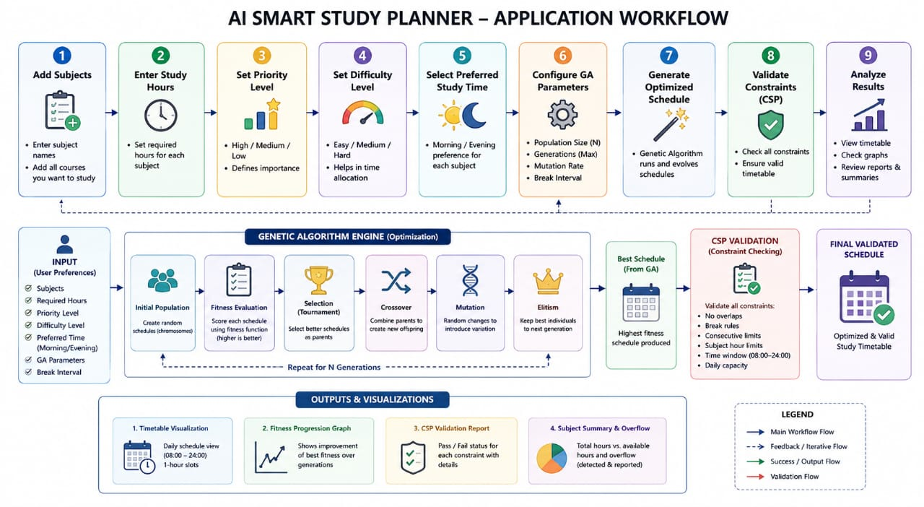
• Output: Timetable, fitness graph, CSP report, and subject summary displayed in GUI.
8. Performance Evaluation
The system is evaluated through the following metrics:
Metric | Description
Fitness Score | Higher score = better schedule; tracked across all generations.
Fitness Convergence | Fitness progression graph shows whether GA converges to a stable optimum.
CSP Violation Count | Number of constraint violations in final schedule (target: 0 violations).
Subject Coverage | All requested subjects present in the final schedule.
Overflow Detection | Subjects with hours exceeding 16-slot daily capacity correctly identified.
Break Compliance | Breaks inserted at correct intervals; no continuous study beyond break_interval hours.

9. Visual Representation of Project
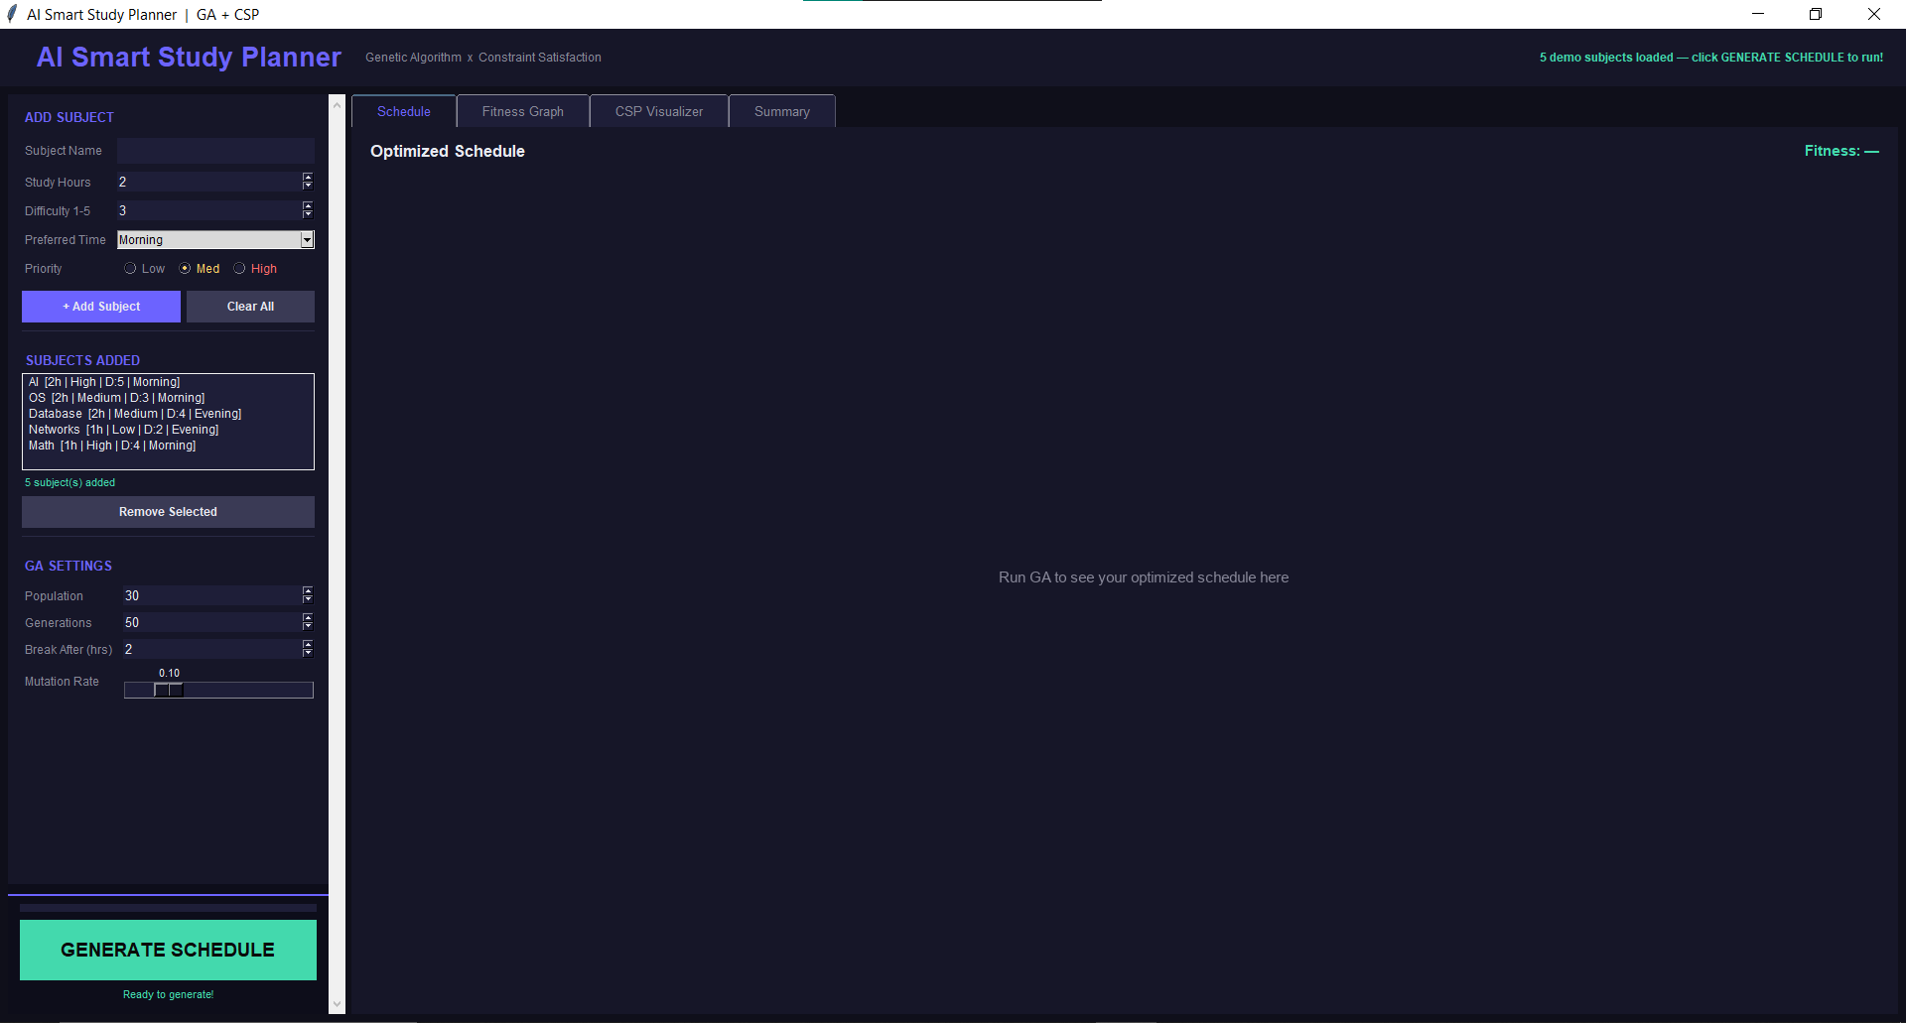
- Main Screen

- Schedule Tab
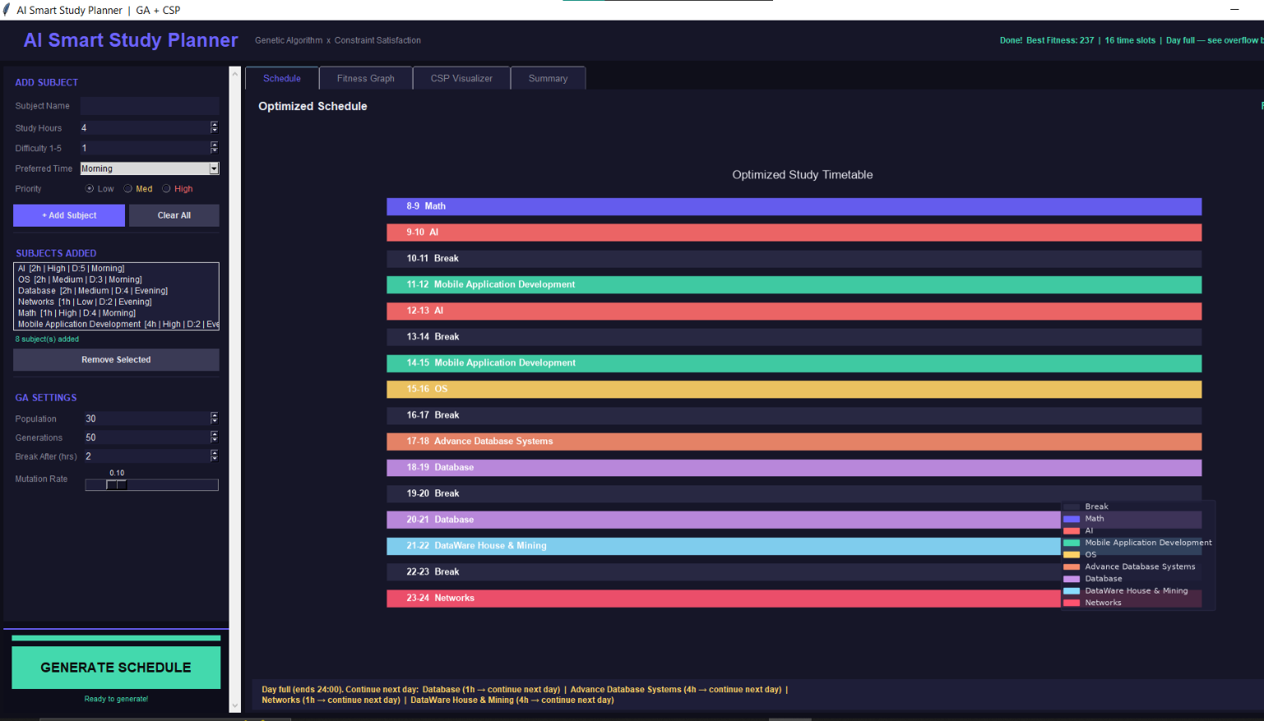
After clicking on Generate Schedule with added courses.

- Fitness Graph Tab
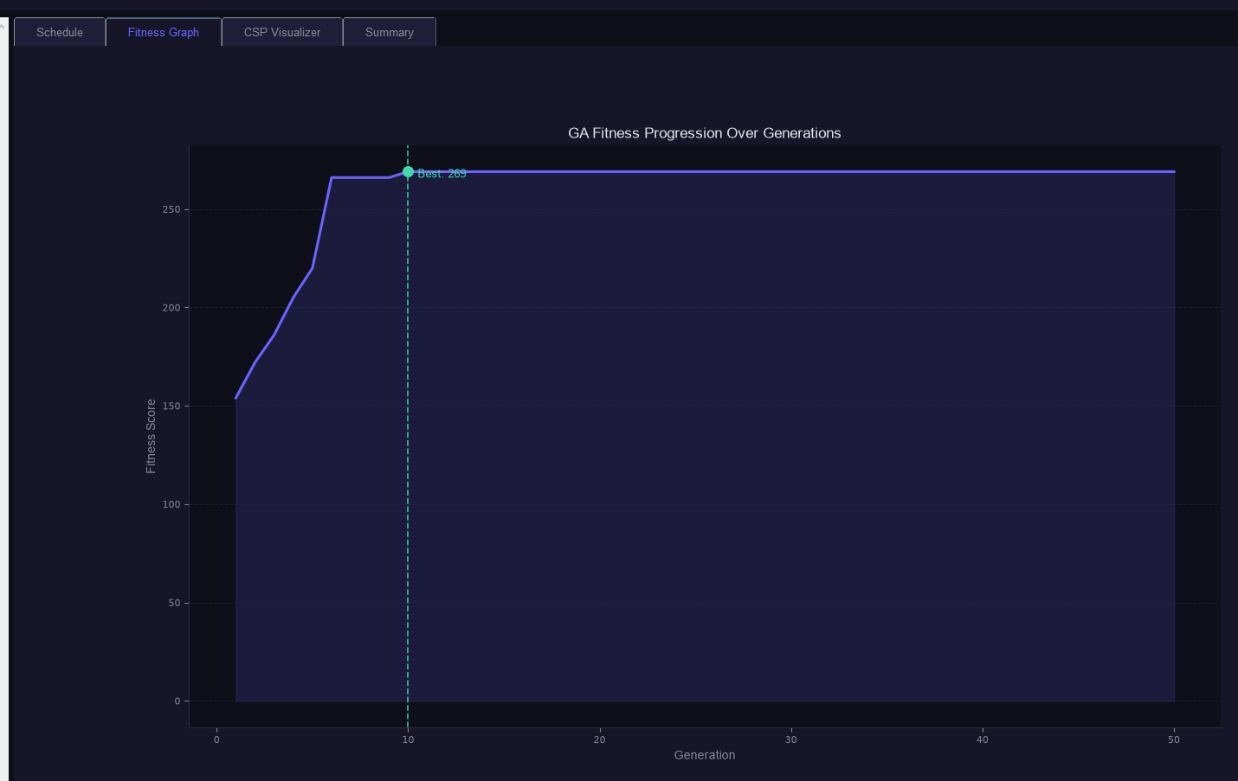

- CSP Visualizer Tab
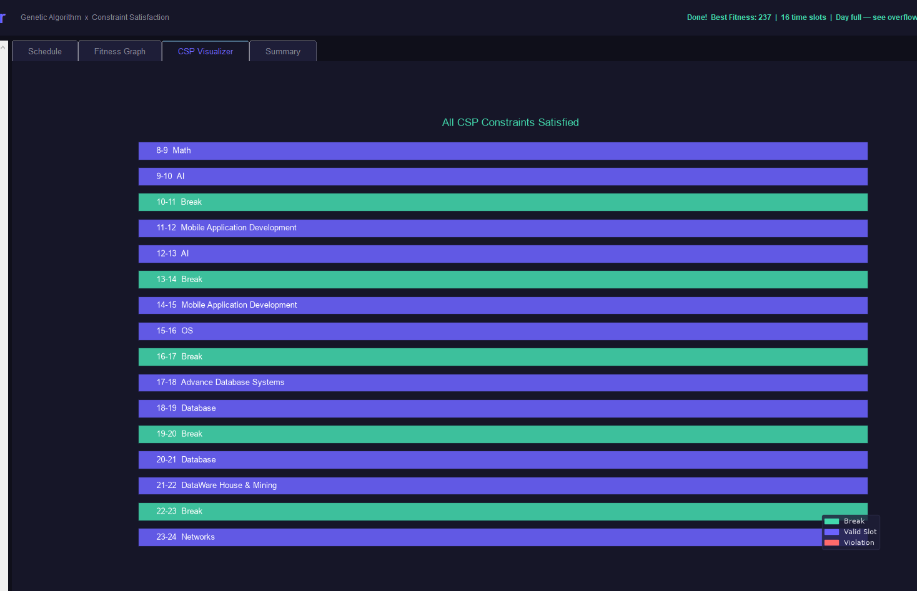
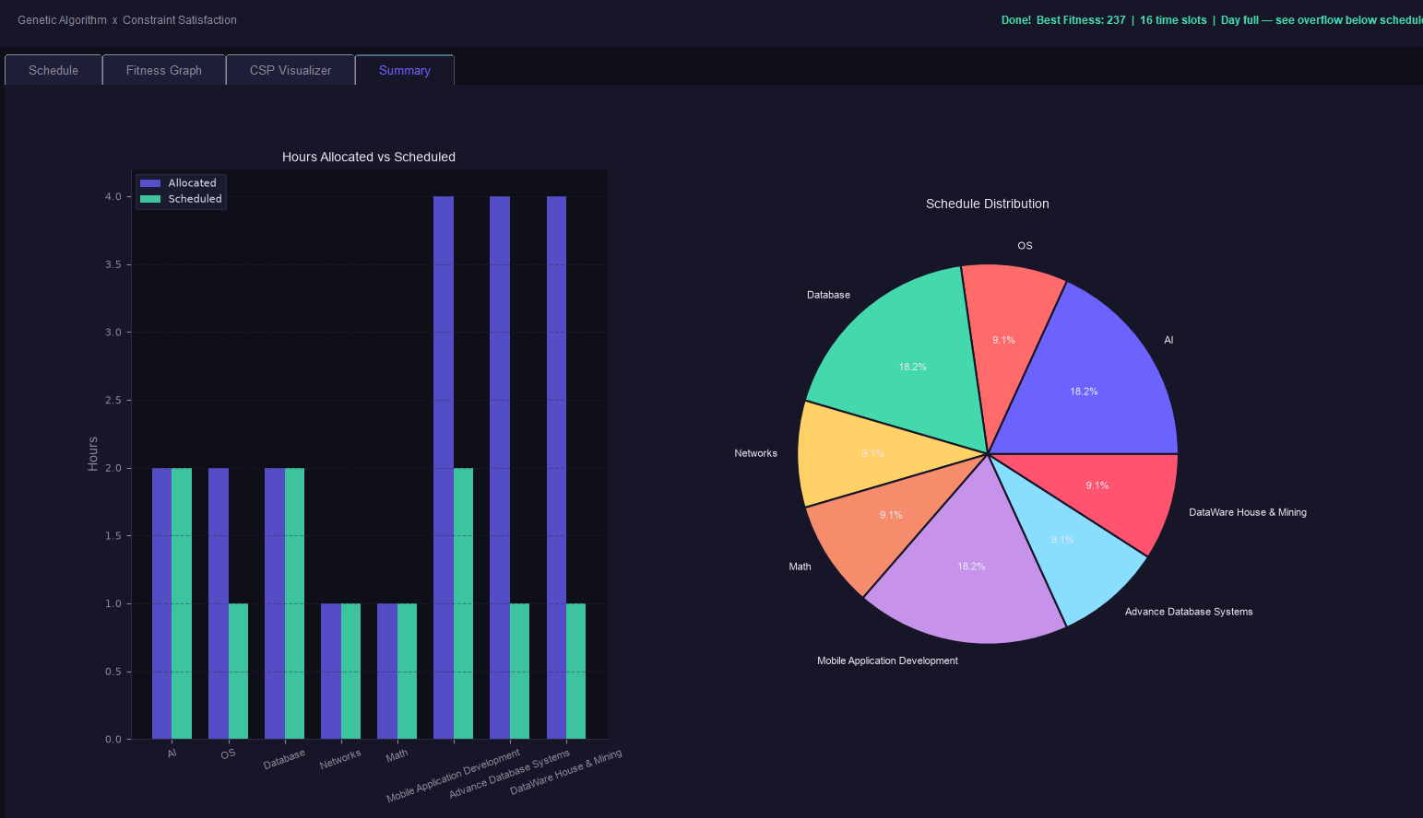
- Summary Tab

